**Shu Qi**

**Taiwanese-Hong Kong actress and model**

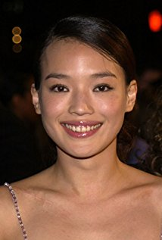

Li-hui or Shu Qi as she is known on stage, is a very beautiful Taiwanese-Hong Kong actress and model with international acclaim. It really doesn’t matter how you spell her name because everyone interested in Asian Films and Television Series know who you are talking about. Her name has been written in a variety of ways including Hsu Chi, Hsu Qi, Qi Shu, and Shu Kei.

She is an astounding actress and is probably the highest paid actress in China. She has appeared in several starring roles in films, dramas and television series. Her younger fans may know her better by her performance in one of her latest films, The Assassin (2015)which won the biggest award in the 2015 Cannes Film Festival. However, she has been around for a while and her rise to top wasn't easy.

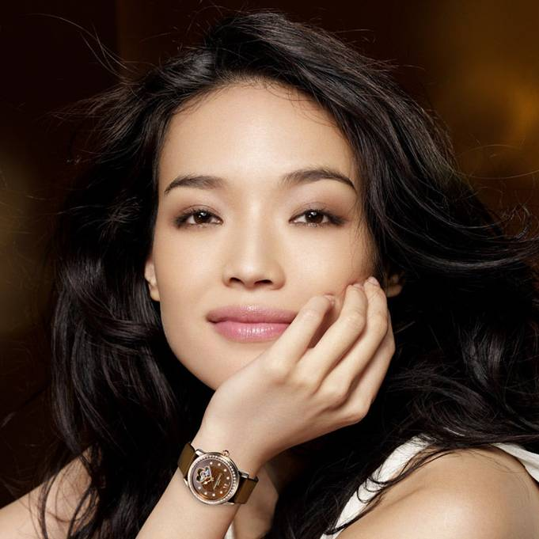

Shu Qi was born in a place now known as New Taipei City in Taiwan on April 16, 1976. She moved in 1994, at an early age, to Hong Kong in search of the ‘Golden Fleece’. Shu Qi is married to a Hong Kong actor-director, Stephen Fung whom she met in 1997 and lived together till 2016 when they formalised the marriage.

Right from the onset, on arrival in Hong Kong, she made it clear that she was very much interested in a career in the film industry and so tried her hands at several small roles including appearing in *Playboy* (China edition) as a porn actress.

She was finally discovered by a Hong Kong film producer, Manfred Wong, who gave her the break she had been waiting for. Wong signed her up with him for roles in several Category III films in Hong Kong including Sex *& Zen* *II* (1996).

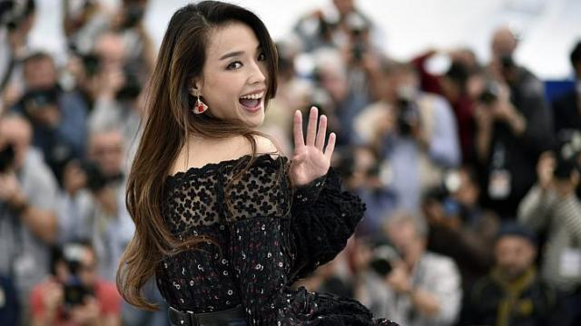

She starred in *Viva Erotica* (1996) alongside Leslie Cheung and Karen Mok. Her performance in this film did not go unnoticed. She was, in 1997, given the Best Supporting Actress awardat the 16th Hong Kong Film Awards.

However she quickly transcended from her roles in soft-core sex films such as *City of Glass* (1998), *Portland Street Blues* (1998), *The Island Tales* (1999) and *Gorgeous* (1999) to mainstream glamorous film industry. Her transition was aided by the huge success of *Gorgeous* (1999) at the box office. This was a romantic comedy movie in which she appeared alongside Jackie Chan.

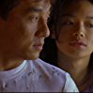

**With Jackie Chan in *Gorgeous* (1999)**

Consequently, she was signed up by Stanley Kwan and Hou Hsiao-hsien for a starring role in the much acclaimed *Millennium Mambo* (2000). From then on she began her phenomenal rise in the Hong Kong and Chinese movie industry.

She broke into the American film market in 2002 when she signed up for a starring role in the French film, *The Transporter* alongside Jason Statham. She followed this up with a memorable performance in *New York, I Love You* (2008), a romantic comedy.



**With Jason Statham in the Movie Transporter**

Back in Asia, she had won the BestActress award at the 2004 13th Shanghai Film Critics’ Awards for her role in *The Foliage* (2004), a historical romance film. She had also played another starring role in *Three Times* (2005) and had won theBest Actress award at the Golden Horse Awards regarded in East Asia as the equivalent of the Oscars.



She appeared in several other films between 2005 and 2008 including the gangster film, *My Wife* *Is a Gangster (*2006)and the crime drama *Confession of Pain*. (2006). With such a great track record, it was no surprise that she was selected to be a jury member at the 2008 Berlin International Film Festival the 2009 Cannes Film Festival.

Recently, she has increased her focus on the Asian market. In 2013, she played the starring role in the film Journey *to the West: Conquering the Demons* (2013), directed by Stephen Chow and based by and large on classic *Journey to* *the West in* Chinese literature.

The film broke box office records in Chinese movie markets to surpass even *Lost in Thailand.* In 2015, apart from in the movie *The* *Assassin* (2015), she also established herself as a face of Chinese acting profession by appearing in several films that were exported to the West. They included movies like the blockbuster film *Mojin: The Lost Legend*. In 2016 she was the star in the Chinese version of *My Best Friend's Wedding* and in the fantasy comedy *The Village of No Return*.

Even at the age of 41 she still looked radiant when she appeared in Stephen Fung's *The Adventurers* alongside Jean Reno and Andy Lau in 2017. Her fans must be delighted to hear that she has been cast in a new science fiction film called *Shanghai Fortress* to be released in 2019.